The Woodlands Texas Stake

April 2021

Dear Brothers and Sisters,

Transition to 2nd Hour Sunday Church Meetings

We are pleased to share with you that the North America Southwest Area presidency, after careful consideration and prayer has authorized the transition to our 2nd Hour Church Meetings. Beginning Sunday May 2nd, 2021 each ward in our stake will resume the second hour of instruction for Sunday School (Adult and Youth), Primary, Relief Society, Aaronic Priesthood and Young Women, and Elders quorums.

The Area Presidency has re-enforced the importance to continue to follow the Safety and Health Guidelines currently in place that will ensure that a safe and sanitary environment is maintained in all church buildings. In addition, in our path forward to transition to 2nd hour Sunday Meetings we have been provided a guideline that requires a minimum amount of time between the end of one ward’s Sunday meetings and the beginning of the next. This temporary schedule adjustment will begin Sunday May 2nd and will allow for 30 minutes between one Ward’s ending time and the next Ward’s start time in order for the necessary cleaning to take place.

The Stake Presidency in counseling with the Bishops and our Stake Council look forward to the blessing to begin to gather together as Ward Families for our normal 2 Hour Sunday Schedule following these new guidelines by our Area Presidency and have received approval from our Area Seventy to move forward.

The temporary new meeting schedule for each ward will be:

Ward Meeting Schedules (To Begin on May 2, 2021)
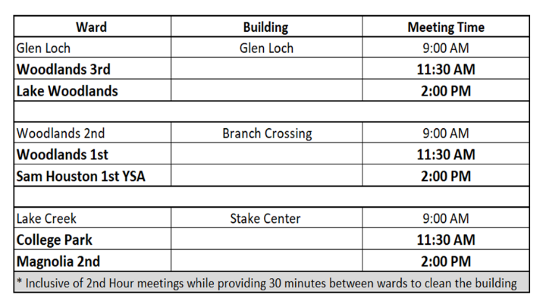

May the Lord continue to bless us, both collectively and individually, as we move into this next phase of worship.

Respectfully,

The Woodlands Texas Stake Presidency

